Bobby Garces (U91631550)

Due: September 19th, 2021

Literature Review of Photonic Technology and Photonic Chips for Machine Learning

Background:

Traditional semiconductor transistor technology has been around since the early 1950s, with integrated circuits coming a decade or so later. Since then, the size and cost of electronic integrated circuits (ICs) have continued to decrease, while the computing capability has increased as larger quantities of transistors are being packed onto chips. IC development has followed Moore’s Law, which states that the number of transistors on a chip will roughly double every two years [11]. However, there has been much discussion about how long the industry will continue to follow Moore’s law as IC design reaches certain limits. Fundamentally, transistor sizes are already approaching the size of silicon atom sizes. The diameter of a silicon atom is approximately 0.2 nm [12], while large semiconductor companies are developing new chips in the range of a few nanometers. Figure 1 shows the progression of microprocessors for the past several decades, with transistor counts still roughly following Moore’s law with the addition of multi-core processors, but clock speeds and power usage steadying. With the demand for faster and more efficient processors continuing to rise as more complex systems and algorithms are developed, transistor technology may not be able to keep up with the demand as the technology reaches it’s physical and technical limits. No one can predict the future, but the potential end of Moore’s law has motivated the scientific community to begin research into alternative technologies that could replace transistor based integrated circuits for microprocessors. The alternative that is the focus of this paper is photonic technology.

Figure 1: 42 Years of Microprocessor Trends

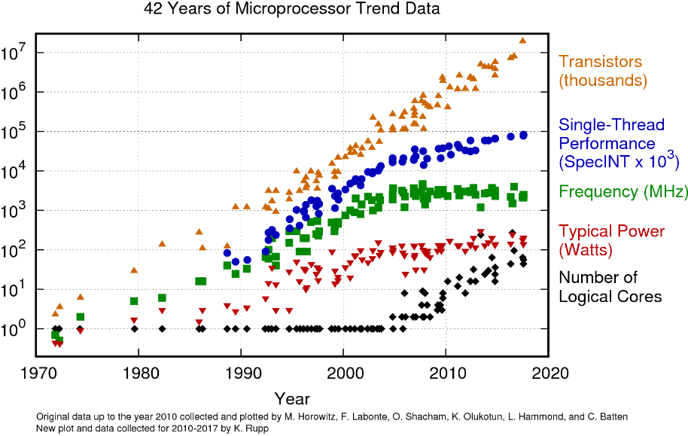

Source: <https://www.karlrupp.net/2018/02/42-years-of-microprocessor-trend-data/>

What are Photonic Integrated Circuits:

Photonic Integrated Circuits (PICs) are “advanced systems-on-a-chip, enabling transmission of data at high speeds, using optical carriers. Operate in visible and near infrared of EM spectrum (350–1650 nm)” [2]. Like electronic integrated circuits, PICs integrate a large number of components onto a compact chip, except in PICs the components are optical rather than electrical. Common PIC components are “optical amplifiers, multiplexers/demultiplexers, lasers, modulators, LEDs, photodetectors, planar optical waveguides, optical fiber, lenses, attenuators, filters, switches.” [2]. Photonic circuits work by using a light source to send photons down a waveguide, similar to how electrons are sent down a wire, and the photons are then refracted, modulated, and measured in various ways to provide a desired output. Current PIC technology is used mainly for data communication in data centers thanks to high speed data transfer up to 100 Gb/s per channel.

Advantages of Photonics:

Since photonic circuits transfer data via photons, rather than electrons, the speeds that can be achieved with photonics is much faster than electronics. Photons are the only particles that can travel at the speed of light, due to being massless, so this gives it an edge over other potential technologies since photonic circuits can take advantage of the fastest possible speed in the universe. In theory, photonic circuits can reach speeds of 10 Tb/s by combining multiple channels of 100 Gb/s [3]. Compare this to the common communication protocol ethernet, which is normally in the range of 100 Mb/s to 1 Gb/s. At least in theory, photonic processors have the potential to be thousands of times faster than traditional microprocessors. Putting these increased speeds in terms of delay times, delays will see a reduction from the order of milliseconds to nanoseconds.

Another advantage of photonics is substantially less power usage. The current energy cost per bit in photonic circuits is in femtojoules (10^-15) [3], and picojoules (10^-12) [7] for traditional electronic circuits. A reduction in energy usage of 1000 times would certainly help reduce the carbon foot print that all technologies of the world produce over their lifetimes. One interesting study found that “training a certain deep neural network for natural-language processing produced five times the CO2 emissions typically associated with driving an automobile over its lifetime” [5]. When put into this perspective it is evident how a 1000x reduction in energy usage would benefit the environment, while also reducing costs.

One other advantage of photonics is the weak interaction amongst photons [1]. This will make having multiple waveguides in parallel and in close proximity easier, unlike electrical wires and signals that consistently need proper shielding and twisted pairs to reduce the noise and interaction between neighboring lines and the external environment.

Disadvantages and Challenges of Photonics:

Like any emerging technology, there are several problems with photonic technology that need to be addressed before PICs will become a staple of modern processing technology.

There are various light source technologies that can be used. Kudyshev talks about the advantage a single source photon emitter would provide in quantum computing, however, “single photon sources proposed so far, which utilize both quantum emitters and nonlinear media, have not yet provided fast and deterministic streams of indistinguishable photons at room temperature” [1]. Without having perfect control of photon emissions across a large range of temperatures the technology would not be beneficial. More readily used light sources are LEDs and lasers. The latter is commonly used for current PIC technology. Since lasers are highly concentrated light beams, thermal management and power consumption need to be addressed to provide a more efficient PIC [3].

There is also a very high cost associated with PIC development. Like the millions of dollars of infrastructure required to manufacture traditional integrated circuits, PIC development is even more expensive due to the new technology and machines required. This hinders the ability for interested personnel (whether it be students, researchers, or companies) from contributing to the development of PIC technology without a large investment. Additionally, according to NASA’s Jet Propulsion Laboratory, component testing and packing of PICs can increase the total cost of production by 60% [2].

Scaling and size may also prove to be a roadblock. According Hamerly, current optical components are tens of micrometers in size [5], while state-of-the-art silicon transistors are nanometers in size. Scaling down optical components can be more difficult than traditional components. To optimize the PICs a large number of components will need to be fit onto a small chip area to provide the computational capability of traditional microprocessors.

Other areas that will need to be addressed are waveguide technology, photodetector sensitivity, and modulating at high speeds across various temperature ranges [3].

Photonic Chips and Machine Learning:

Machine learning is using mathematical models to fit a model to a complex set of data, and then using this refined model to predict outcomes. Machine learning and artificial intelligence technology has been exploding in the past few decades. With applications such as pattern recognition, image recognition, language processing, analysis of large datasets, and autonomous systems [4][10]. It has become so mainstream that nearly every person deals with machine learning technology daily, such as smart assistants like Siri, Alexa, and Google Home. However, computing demands of machine learning are rising faster than technology can provide. Many companies are searching for solutions to this problem, such as Google developing a Tensor Processing Unit (TPU), which is an integrated circuit specifically for neural networks.

Some believe that photonics is the future of the machine learning industry. A common machine learning method is called neural networks, which involve multiple layers of nodes with interconnections between nodes that ultimately lead to a series of outputs based on the inputs. As Hamerly states, “ the benefit of arranging things that way, as opposed to allowing connections between any two neurons, is that it allows certain mathematical tricks of linear algebra to be used to speed the calculations” [5]. The matrix operations that are involved for neural network training and inference have been optimized well in electronic processors, but there are alternatives. Thanks to the advantages mentioned earlier in this paper, matrix operations can be done much faster with photons rather than electrons. An example given by Ferreira de Lima mentions that a certain image classification task can take weeks to train properly and still only achieve an accuracy of ~80% [3]. If processing speeds can’t keep up, these absurd training times will continue to increase. The real time applications of machine learning, say in self driving cars, will also benefit from improved computational speeds. As various autonomous systems become more complex, without the computational power to operate in real time the advanced algorithms will be useless.

In the last paragraph the use of photonic circuits to improve machine learning speeds is talked about, but what about the reverse? Can machine learning be used to improve photonic technology? In the paper “Machine Learning and Applications in Ultrafast Photonics” the potential to use machine learning algorithms to improve ultrafast photonics is discussed. The reasoning behind using machine learning is because “phenomena in photonics are nonlinear and multidimensional, with noise-sensitive dynamics that are extremely challenging to model using conventional methods” [4]. One area where machine learning would help is in the optimizing and self-tuning of ultrafast fibre lasers. The desire is to have a precise, fully autonomous system that can handle dynamic laser emissions even in the presence of external factors.

Conclusion:

Photonic technology is already used widely in the data communications industry, and for good reason. Photonics provides extremely high data speeds at low energy costs. With the recent development of photonic integrated circuits, the possibility of harnessing photonics for greater computational speeds in microprocessors is becoming more of a reality. There is still much development needed in the field before photonic circuits will become prominent, but if researchers can solve the aforementioned issues and develop photonics-based microprocessors that would mean a new era for technology. Computers, phones, control systems, machine learning, really anything that uses chips for processing would be able to take a large step in developments.

References:

1. ACS Photonics. “Machine Learning for Integrated Quantum Photonics” ACS Publications, 24 December 2020, <https://doi.org/10.1021/acsphotonics.0c00960>
2. Bozovich, Amanda. “Photonic Integrated Circuits (PICs) for Next Generation Space Applications” NASA Jet Propulsion Laboratory (JPL), 16 June 2020, https://nepp.nasa.gov/workshops/etw2020/talks/16-JUN-TUE/1345-Bozovich-NEPP%20ETW-CL20-2424-Photonics-v2.pdf
3. Ferreira de Lima, Thomas, et al. "Machine Learning With Neuromorphic Photonics," in Journal of Lightwave Technology, vol. 37, no. 5, pp. 1515-1534, 1 March 2019, <https://ieeexplore.ieee.org/abstract/document/8662590>
4. Genty, G., Salmela, L., Dudley, J.M. et al. “Machine learning and applications in ultrafast photonics.” Nat. Photonics 15, 91–101 (2021). <https://doi.org/10.1038/s41566-020-00716-4>
5. Hamerly, Ryan. “The Future of Deep Learning Is Photonic.” *IEEE Spectrum*, IEEE Spectrum, 4 Aug. 2021, <https://spectrum.ieee.org/the-future-of-deep-learning-is-photonic>
6. Hamerly, R. et al. “Large-Scale Optical Neural Networks based on Photoelectric Multiplication.” ArXiv abs (2018), <https://journals.aps.org/prx/pdf/10.1103/PhysRevX.9.021032>
7. Jiang, Wentao. “Energy to Transmit One Bit” Standford, 10 November 2018, <http://large.stanford.edu/courses/2018/ph240/jiang1/>
8. Miscuglio, Mario. "Photonic tensor cores for machine learning" Applied Physics Reviews 7, 21 July 2020, <https://doi.org/10.1063/5.0001942>
9. Ploeg, Sequoia, et al. “Simphony: An open source photonic integrated circuit simulation framework” Brigham Young University, 23 July 2020, <https://arxiv.org/pdf/2009.05146.pdf>
10. Schneider, David. “Deep Learning at the Speed of Light.” *IEEE Spectrum*, IEEE Spectrum, 28 July 2021, <https://spectrum.ieee.org/deep-learning-at-the-speed-of-light>
11. “Moore's Law.” *Wikipedia*, Wikimedia Foundation, 9 Sept. 2021, <https://en.wikipedia.org/wiki/Moore%27s_law>
12. “Silicon.” *Wikipedia*, Wikimedia Foundation, 8 Sept. 2021, <https://en.wikipedia.org/wiki/Silicon>